

**WARRANTY CLAIMS FRAUD PREDICTION**

**AN INTERNSHIP PROJECT REPORT**

***Submitted by***

**DINESH M 110821205011**

***in partial fulfilment for the award of the degree***

***of***

**BACHELOR OF TECHNOLOGY**

***in***

INFORMATION TECHNOLOGY

**JAYA ENGINEERING COLLEGE, THIRUNINRAVUR**

**ANNA UNIVERSITY CHENNAI 600 025**

**JULY 2024**

ANNA UNIVERSITY CHENNAI 600 025

**BONAFIDE CERTIFICATE**

Certified that this Internship Project report **“WARRANTY CLAIMS FRAUD PREDICTION”** is the bonafide work of, **“DINESH M (110821205011)”** who carried out the project under my supervision.

|  |  |
| --- | --- |
| **SIGNATURE OF INTERNAL EXAMINER** | **SIGNATURE OF EXTERNAL EXAMINER** |
| **Dr. SEEDHA DEVI V, Asso.Prof.,** |  |
| **HEAD OF THE DEPARTMENT,** |  |
| Dept. of Information Technology, |  |
| Jaya Engineering College, |  |
| Thiruninravur 602024, |  |
| Chennai. |  |

**ABSTRACT**

Warranty claims fraud prediction involves utilizing data analytics and machine learning techniques to identify and prevent fraudulent activities within warranty claims processes. This predictive approach aims to enhance the accuracy of fraud detection by analyzing patterns and anomalies in claim data. By integrating historical claim records, customer profiles, and transaction details, predictive models can identify suspicious patterns that deviate from normal claim behaviors. Techniques such as supervised learning, unsupervised learning, and anomaly detection are employed to forecast potential fraud risks and flag irregularities for further investigation. The goal is to reduce financial losses and improve the efficiency of warranty management systems by proactively addressing fraud before it escalates. This approach not only safeguards company resources but also ensures fairness and integrity in warranty services.

Warranty claims fraud prediction leverages advanced analytical methodologies to detect and mitigate fraudulent activities in the warranty claims process. By employing techniques such as data mining, machine learning, and statistical analysis, organizations can systematically scrutinize warranty claim submissions for irregularities and patterns indicative of fraud. This predictive framework involves analyzing vast datasets, including historical claims, repair records, and customer interactions, to develop models that highlight deviations from expected behaviors. The integration of these models into the claims management system enables real time fraud detection, reducing false claims and associated costs. Ultimately, this approach enhances the integrity of warranty programs, ensures equitable treatment of legitimate claims, and protects organizational assets from financial fraud.

**KEYWORDS**

Warranty claims ,Fraud detection ,Predictive analytics ,Claim irregularities ,Financial losses ,Warranty integrity.

窗体顶端

窗体底端

**TABLE OF CONTENTS**

|  |  |  |
| --- | --- | --- |
| **CHAPTER NO.** | **TITLE** | **PAGE NO.** |
| **I** | **INTRODUCTION** | **1** |
|  | * 1. Key Components to Data Science   2. Data Science Job | 1  2 |
| **II** | **SYSTEM REQUIREMENTS** | **6** |
|  | 2.1 Feasibility Study  2.2 Hardware and Software Requirements | **6**  **7** |
| **III** | **SYSTEM DESIGN** | **10** |
|  | 3.1 System Architecture  3.2 Modules  3.3 Algorithms Used | 10  **11**  **12** |
| **IV** | **SYSTEM IMPLEMENTATION** | **17** |
|  | 4.1 Sample Codes  4.2 Procedure for Execution | 17  **34** |
| **V** | **CONCLUSION FOR FUTURE ENHANCEMENT**  **APPENDICES** | **37** |
|  | **APPENDIX I**  **APPENDIX II** | **38**  **51** |
|  |  |  |

**TABLE OF FIGURES**

|  |  |  |
| --- | --- | --- |
| **FIG.NO.** | **TITLE** | **PAGE NO.** |
|  |  |  |
|  |  |  |
|  |  |  |
|  |  |  |
|  |  |  |
|  |  |  |
|  |  |  |
|  |  |  |
|  |  |  |
|  |  |  |
|  |  |  |
|  |  |  |
|  |  |  |
|  |  |  |
|  |  |  |
|  |  |  |
|  |  |  |
|  |  |  |
|  |  |  |
|  |  |  |
|  |  |  |
|  |  |  |

**CHAPTER I**

**INTRODUCTION**

**1.INTRODUCTION TO DATA SCIENCE**

Data is widely considered a crucial resource in different organizations across every industry. Data Science can be described in simple terms as a separate field of work that deals with the management and processing of data using statistical methods, artificial intelligence, and other tools in partnership with domain specialists. Pursuing Data Science encompasses concepts and epochs derived from different fields including Mathematics and Computer Science and Information Theory to interpret large data.

Data Science can help businesses gain insights and knowledge to make the right decisions, improve processes, and build models that can fuel advancements in the commercial world.

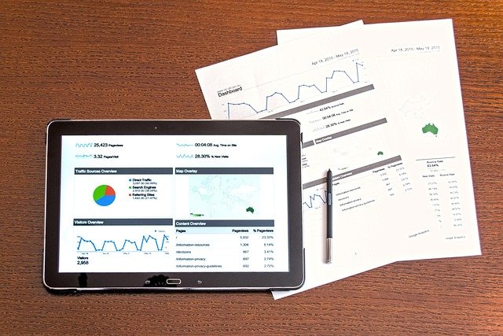

**1.1 Key Components of Data Science**

**1.1.1 Foundational Concepts**

Introduction to basic concepts in data science, including data types, data manipulation, data cleaning, and exploratory data analysis.

**1.1.2 Programming Languages**

Instruction in programming languages commonly used in data science, such as Python or R. Students learn how to write code to analyze and manipulate data, create visualizations, and build machine learning models.

**1.1.3 Statistical Methods**

Coverage of statistical techniques and methods used in data analysis, hypothesis testing, regression analysis, and probability theory.

**1.1.4 Machine Learning**

Introduction to machine learning algorithms, including supervised learning, unsupervised learning, and deep learning. Students learn how to apply machine learning techniques to solve real world problems and make predictions from data.

**1.1.5 Data Visualization**

Instruction in data visualization techniques and tools for effectively communicating insights from data. Students learn how to create plots, charts, and interactive visualizations to explore and present data.

**1.1.6 Practical Projects**

Hands on experience working on data science projects and case studies, where students apply their knowledge and skills to solve real world problems and analyze real datasets.

**1.1.7 Capstone Project**

A culminating project where students demonstrate their mastery of data science concepts and techniques by working on a comprehensive project from start to finish.

**1.2 Data Science Job**

A data science job involves using various techniques, algorithms, and tools to extract insights and knowledge from structured and unstructured data. Here are some of the key data science job roles

**1.2.1 Data Scientist**

* **Responsibilities:** Analyzing large datasets, developing machine learning models, interpreting results, and providing insights to inform business decisions.
* S**kills:**  Proficiency in programming languages like Python or R, expertise in statistics and machine learning algorithms, data visualization skills, and domain knowledge in the relevant industry.

**1.2.2 Data Analyst**

* **Responsibilities:**  Collecting, cleaning, and analyzing data to identify trends, patterns, and insights. Often involves creating reports and dashboards to communicate findings to stakeholders.
* **Skills:**  Strong proficiency in SQL for data querying, experience with data visualization tools like Tableau or Power BI, basic statistical knowledge, and familiarity with Excel or Google Sheets.

**1.2.3 Machine Learning Engineer**

* **Responsibilities:**  Building and deploying machine learning models at scale, optimizing model performance, and integrating them into production systems.
* **Skills:** Proficiency in programming languages like Python or Java, experience with machine learning frameworks like TensorFlow or PyTorch, knowledge of cloud platforms like AWS or Azure, and software engineering skills for developing scalable solutions.

**1.2.4 Data Engineer**

* **Responsibilities:**  Designing and building data pipelines to collect, transform, and store large volumes of data. Ensuring data quality, reliability, and scalability.
* **Skills:**  Expertise in database systems like SQL and NoSQL, proficiency in programming languages like Python or Java, experience with big data technologies like Hadoop or Spark, and knowledge of data warehousing concepts.

**1.2.5 Business Intelligence (BI) Analyst**

* **Responsibilities:** Gathering requirements from business stakeholders, designing and developing BI reports and dashboards, and providing data driven insights to support strategic decision making.
* **Skills:** Proficiency in BI tools like Tableau, Power BI, or Looker, strong SQL skills for data querying, understanding of data visualization principles, and ability to translate business needs into technical solutions.

**1.2.6 Data Architect**

* **Responsibilities:**  Designing the overall structure of data systems, including databases, data lakes, and data warehouses. Defining data models, schemas, and data governance policies.
* **Skills:**  Deep understanding of database technologies and architectures, experience with data modeling tools like ERWin or Visio, knowledge of data integration techniques, and familiarity with data security and compliance regulations.

**CHAPTER II**

**SYSTEM REQUIREMENTS**

**2.1 Feasibility Study**

**2.1.1 Project Objectives**

**Purpose:**  The Warranty Claims Fraud Prediction System aims to utilize advanced data analytics and machine learning to detect and prevent fraudulent warranty claims, improving accuracy and reducing financial losses.

**Goals:** Develop accurate predictive models to identify fraud, enhance operational efficiency by automating detection processes, and ensure seamless integration with existing systems while maintaining data privacy and fairness.

**Objective:** Achieve significant cost savings, streamline claims management, and continuously improve system performance to protect organizational resources and ensure the integrity of warranty services.

**2.1.2 Requirements**

**1.Functional Requirements**

· **1.**Data Integration and Management****

* ****Data Collection:****  The system must collect and integrate data from various sources, including historical warranty claims, customer profiles, repair records, and transaction logs.
* ****Data Storage:****  Provide secure and scalable storage solutions for managing large volumes of data with efficient retrieval mechanisms.
* ****Data Preprocessing:****  Implement data cleaning, normalization, and transformation processes to prepare data for analysis and modeling.

**2.**Predictive Modeling and Analysis****

* ****Model Development:****  Support the development of machine learning models for fraud detection, including supervised learning (e.g., classification algorithms), unsupervised learning (e.g., clustering), and anomaly detection.
* ****Model Training and Testing:**** Allow for the training, validation, and testing of predictive models using historical data to ensure accuracy and reliability.
* ****Real Time Analysis:****  Enable real time analysis of incoming claims to identify potential fraud during the claims process.

·  **3.**Fraud Detection and Alerting****

* ****Anomaly Detection:****  Identify and flag anomalies and patterns indicative of fraudulent activity based on established criteria and learned patterns.
* ****Risk Scoring:****  Assign risk scores to claims based on the likelihood of fraud, providing a basis for further investigation.
* ****Alert System:****  Generate automated alerts and notifications for suspicious claims, allowing claims adjusters to take appropriate actions.

· **4.**User Interface and Interaction****

* ****Dashboard:****  Provide a user friendly dashboard for monitoring fraud detection metrics, viewing flagged claims, and accessing system performance reports.
* ****Claim Review :**** Enable claims adjusters to review detailed information on flagged claims, including risk scores, detected anomalies, and historical data.
* ****User Management:**** Support role based access control to ensure appropriate access to system features and data based on user roles and permissions.

**· 5.**Integration and Compatibility****

* ****System Integration:****  Ensure seamless integration with existing claims management systems, CRM platforms, and other relevant IT infrastructure.
* ****API Support:****  Provide APIs for data exchange and integration with external systems and third party tools.

·  **6.**Data Privacy and Security****

* ****Data Encryption:****  Implement encryption protocols to protect sensitive data both in transit and at rest.
* ****Access Control:****  Enforce strict access controls and authentication mechanisms to safeguard against unauthorized access.
* ****Compliance:****  Adhere to data protection regulations and standards such as GDPR and CCPA to ensure legal compliance.

**· 7.**Reporting and Analytics****

* ****Fraud Reports:****  Generate comprehensive reports on fraud detection performance, including metrics such as detection rates, false positives, and financial impact.
* ****Analytics Tools:****  Provide analytical tools for investigating fraud trends, model performance, and operational efficiency.

**· 8.**Maintenance and Support****

* ****System Updates:**** Facilitate regular updates and maintenance of the predictive models and system software to adapt to new fraud patterns and technological advancements.
* ****Technical Support:**** Offer technical support and troubleshooting services to address any issues encountered by users.

**2.Non Functional Requirements**

### **1. **Performance****

* ****Response Time:****  The system should analyze and generate fraud predictions within a specified time frame, such as 5 seconds per claim.
* ****Scalability:****  The system should be able to handle an increasing number of warranty claims and users without significant degradation in performance.
* ****Throughput:****  The system should be capable of processing a high volume of claims per minute, for instance, 10,000 claims per hour.

### **2. **Reliability****

* ****Availability**:**  The system should be available 99.9% of the time, with minimal downtime for maintenance.
* ****Fault Tolerance:****  The system should be able to recover from failures and continue functioning with minimal impact on operations.
* ****Data Integrity:****  The system must ensure that all data processed is accurate and consistent.

### **3. **Security****

* ****Data Protection**:**  The system should comply with data protection regulations (e.g., GDPR, CCPA) and ensure that personal and sensitive information is encrypted and securely stored.
* ****Access Control:****  The system should have robust authentication and authorization mechanisms to ensure that only authorized personnel can access or modify sensitive data.
* ****Audit Trails:****  The system should maintain detailed logs of all transactions and user activities for audit and compliance purposes.

### **4. **Usability****

* ****User Interface:****  The system should have an intuitive and user friendly interface to allow users to easily input, review, and analyze warranty claims.
* ****Training:****  Comprehensive training materials and support should be provided to users to ensure they can effectively use the system.

### **5. **Maintainability****

* ****Modularity:****  The system should be designed in a modular fashion to facilitate easy updates and maintenance.
* ****Documentation:****  Detailed documentation should be available for both end users and developers to support system maintenance and future enhancements.

### **6. **Compatibility****

* ****Integration:****  The system should be compatible with existing enterprise systems and databases, allowing for seamless integration and data exchange.
* ****Platform Independence:****  The system should be able to run on multiple operating systems and devices if applicable.

### **7. **Scalability****

* ****Load Handling:****  The system should be able to scale horizontally or vertically to handle increased loads without performance degradation.
* ****Resource Management:****  The system should efficiently manage computing resources to optimize performance and cost.

### **8. **Compliance****

* ****Regulatory Compliance:****  The system should adhere to relevant industry standards and regulations related to fraud detection and data management.
* ****Audit Compliance:**** The system should be able to support audit requirements by providing necessary documentation and traceability.

### **10. **Ethical Considerations****

* ****Bias Mitigation:****  The system should be designed to minimize biases in fraud detection to ensure fair and unbiased predictions.
* ****Transparency**:**  The system should provide explanations or justifications for its predictions to maintain transparency and trust.

**3. Technical Feasibility**

* **Python Libraries and Tools** 
  + Data Processing Pandas, NumPy
  + Machine Learning Scikit learn, TensorFlow, PyTorch
  + Visualization Matplotlib, Seaborn, Plotly
  + Web Frameworks Flask, Django
  + Database SQLite, PostgreSQL
* **Infrastructure**
  + **Hardware:** Assess requirements for computational resources (CPU/GPU).
  + **Software:** Ensure required Python libraries and tools are compatible with the system’s infrastructure.

**4. Economic Feasibility**

* **Cost Analysis**
  + **Development Costs:** Estimate costs for development, testing, and deployment.
  + **Operational Costs:** Consider ongoing costs for data storage, processing, and maintenance.
* **Funding** 
  + **Budget:**  Identify potential funding sources or grants for the project.
* **Cost Benefit Analysis**
* ****Cost Benefit Summary:****  The project’s initial investment of $500,000 in development and deployment is expected to generate annual benefits of $800,000 through reduced fraud losses and improved operational efficiency.
* ****ROI and Payback:****  With an estimated ROI of 33.33% and a payback period of approximately one year, the project demonstrates a strong financial return and quick recovery of initial costs.
* ****Long Term Value:****  Beyond immediate financial gains, the system enhances customer trust and operational effectiveness, providing lasting strategic advantages and risk mitigation.

**5. Risk Analysis**

**· **Data Quality Risks:****  Inaccurate or incomplete data may lead to flawed fraud detection models, resulting in false positives or missed fraudulent claims, impacting the system’s reliability.

**· **Integration Challenges:****  Difficulty in integrating the new system with existing ERP and CRM platforms could cause delays and operational disruptions, affecting the overall effectiveness and adoption.

**6. Implementation Plan**

**· **Development and Testing:****  Build and train the fraud detection models, followed by rigorous testing to ensure accuracy and reliability, using historical data and simulated scenarios.

**· **Integration and Deployment:****  Seamlessly integrate the system with existing ERP and CRM platforms, ensuring smooth data flow and user adoption, and deploy the solution across the organization.

**· **Monitoring and Optimization**:**  Continuously monitor system performance, address any issues, and optimize algorithms and processes based on feedback and evolving fraud patterns.

**8. Evaluation and Monitoring**

**· **Performance Metrics**:**  Regularly assess system accuracy, false positive/negative rates, and processing speed against predefined benchmarks to ensure effectiveness.

**· **User Feedback:****  Collect and analyze feedback from end users to identify issues, improve usability, and adjust the system based on practical insights.

·  ****Continuous Improvemen:****  Implement ongoing model updates and refinements based on new data and emerging fraud trends to enhance detection capabilities and maintain system relevance.

**2.2 HARDWARE AND SOFTWARE**

**2.2.1 Hardware Requirements**

· ****Processing Power****

****CPU:****  Multi core processors (e.g., Intel Xeon or AMD EPYC) for handling intensive data processing and machine learning tasks.

****GPU:****  High performance GPUs (e.g., NVIDIA Tesla or NVIDIA A100) if utilizing deep learning algorithms or requiring significant parallel processing capabilities.

**· **Memory****

****RAM****  At least 64 GB of RAM for handling large datasets and ensuring smooth operation of data processing and machine learning tasks. Higher memory may be required for larger datasets.

**· **Storage****

****Primary Storage:****  SSDs (Solid State Drives) for fast data access and processing. Storage capacity should be scalable, starting from 1 TB and extending based on data growth.

****Secondary Storage:**** High capacity HDDs (Hard Disk Drives) or cloud storage solutions for long term data retention and backups.

**· **Networking****

· **Network Interface Cards (NICs)**  High speed NICs (e.g., 10 Gbps Ethernet) to handle large data transfers and maintain efficient connectivity between servers and data sources.

**Operating System**

* **Windows:** Windows 7 or later.
* **macOS:** macOS Catalina (10.15) or later.
* **Linux**: A stable distribution like Ubuntu 20.04 LTS or later, or CentOS.

**CHAPTER 3**

**SYSTEM DESIGN**

**System architecture**

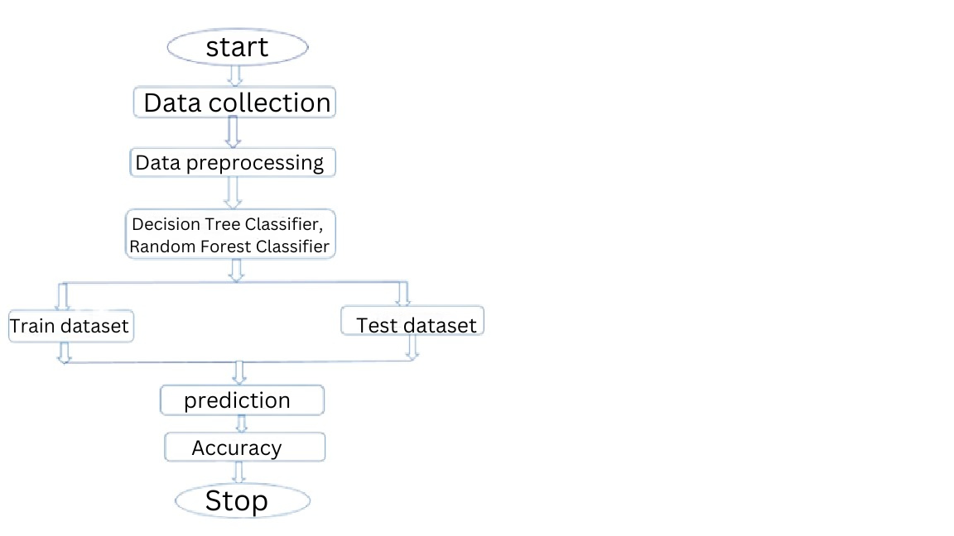

Certainly! Here's a detailed explanation of each step in the flowchart you provided

**1. Start**

This is the initiation of the machine learning process. It signifies the beginning of the workflow.

**2. Data Collection**

**Purpose:** Gathering relevant data that will be used to train and test the machine learning models.

**Details:** Data collection can involve extracting data from databases, collecting data through sensors or APIs, or downloading publicly available datasets. The quality and quantity of data collected at this stage are crucial as they directly impact the model's performance.

**3. Data Preprocessing**

**Purpose:** Preparing the raw data for analysis by cleaning and transforming it into a suitable format.

**Details:** This step involves several sub processes

**Data Cleaning:**  Handling missing values, removing duplicates, and correcting errors.

**Data Transformation:** Normalizing or standardizing the data, encoding categorical variables, and transforming data types.

**Feature Selection/Engineering**: Selecting the most relevant features or creating new features that better represent the data.

**Outcome:** The data is transformed into a format that can be fed into machine learning algorithms for training.

**4. Model Selection**

**Purpose:** Choosing the appropriate machine learning algorithms for the task.

**Decision Tree Classifier:** A tree like model of decisions that splits the data into subsets based on the value of input features. It's easy to interpret but may overfit on complex datasets.

**Random Forest Classifier:** An ensemble learning method that combines multiple decision trees to improve accuracy and robustness. It reduces the risk of overfitting compared to a single decision tree.

**Outcome:** The selected models will be trained using the dataset.

1. **Data Splitting**

**Purpose:** Dividing the dataset into two parts one for training the model and one for testing its performance.

**Train Dataset:** Used to train the machine learning model. The model learns patterns and relationships in this data.

**Test Dataset:** Used to evaluate the model’s performance after it has been trained. This dataset helps to assess how well the model generalizes to new, unseen data.

**Outcome:** The data is split, typically in a ratio like 70 30 or 80 20 for training and testing, respectively.

**6. Prediction**

**Purpose:** Using the trained model to make predictions on the test dataset.

**Details:** The model, once trained, takes in new data (from the test dataset) and predicts the outcome based on what it has learned during training. This step is where the model is applied to unseen data to see how well it performs.

**7. Accuracy**

**Purpose:** Measuring the model’s performance by comparing its predictions with the actual outcomes.

**Detail:** Accuracy is a common metric used to evaluate classification models, calculated as the ratio of correctly predicted instances to the total instances.

Other evaluation metrics like precision, recall, F1 score, and confusion matrix might also be used depending on the problem.

**Outcome:** The accuracy of the model gives an indication of how well it performs on the test data, which helps in deciding if the model is suitable for deployment or if further tuning is needed.

**8. Stop**

**Purpose:** Concluding the workflow after evaluation.

**Details:** This marks the end of the machine learning process. If the model's performance is satisfactory, the process ends here. Otherwise, the workflow may iterate back to previous steps for improvements, like tweaking the model, collecting more data, or refining preprocessing steps.

This flowchart represents a typical workflow in a machine learning project, focusing on classification tasks with decision tree and random forest classifiers. The process involves iterative steps to ensure the model is accurate and reliable for real world applications.

**Start** Initiates the warranty claim fraud prediction process.

· ****Data Collection:****

* **Collect Claim Information** Gather details about the warranty claim.
* **Collect Product Information** Obtain data about the product involved.
* **Collect Claimant Information** Record details about the claimant.
* **Collect External Data** Acquire data from fraud detection databases and other sources.
* **Collect System Data** Gather logs and interaction data from the warranty claim system.
* **Collect Environmental Data** Record geographic and temporal data related to the claim.

**· **Data Preprocessing** :**

* **Data Cleaning** Correct errors and inconsistencies in the data.
* **Data Integration** Combine data from different sources into a unified format.
* **Feature Engineering** Create new features or variables from raw data.
* **Data Enrichment** Enhance data with additional information.

· ****System Integration:****

* **Integrate Data** Incorporate the preprocessed data into the fraud detection system.
* **Integrate Models** Deploy fraud detection models into the system.
* **Integrate APIs** Connect with external services or tools for additional data or functionalities.

**· **Model Development****

* ****Train Models:****  Develop machine learning models using historical data.
* ****Validate Models:**** Assess model performance and accuracy.

**· **Fraud Detection****

* ****Apply Predictive Models:**** Use trained models to evaluate new claims.
* ****Fraud Detection & Classification:**** Identify and classify potential fraud.

****Outcome****

* 1. **Approve Claim** If the claim is verified as legitimate.
  2. **Reject Claim** If the claim is determined to be fraudulent.
  3. **Review Needed** If further investigation is required.
  4. **Flag for Investigation** If the claim requires manual review or additional checks.
  5. **Take Actions** Implement actions based on the outcome, such as legal measures or corrective actions.

**End** Conclude the process based on the outcome.

This flowchart outlines the major steps in the warranty claim fraud prediction process, from initial data collection to final outcomes. Each stage is essential for ensuring that the fraud detection system is effective and accurate.

Warranty Claim Fraud Prediction Project Detailed Module Outline

**1. Problem Definition**

**Objective:** Develop a machine learning model that can predict whether a warranty claim is fraudulent or legitimate. The goal is to minimize financial losses due to fraudulent claims while maintaining customer trust.

**Challenges:** Imbalanced Data Fraud cases are usually much less frequent than legitimate claims.

Complex Patterns Fraudulent behavior may involve subtle patterns that are difficult to detect.

**Data Privacy:** Ensuring compliance with data protection regulations while handling sensitive customer and transaction data.

**2. Data Collection**

**Internal Sources:**

Warranty claims databases (including historical claim data).

Customer relationship management (CRM) systems.

Product lifecycle management (PLM) systems.

Customer service and repair records.

**External Sources**

Socio demographic data (e.g., from public databases or third party providers).

Market data that might influence fraudulent behavior.

**Data Fields to Collect**

**Customer Information**

Customer ID, age, gender, location, purchase history.

Previous claims history, including frequency and outcomes.

**Product Information**

Product ID, type, model, purchase date, warranty period, price.

**Claim Details**

Claim ID, claim date, claimed amount, issue reported, resolution outcome.

Service provider details, parts replaced, and repair records.

**Other Relevant Data**

Time since last claim, number of claims on the same product, and claim approval rate.

**Data Acquisition**

**Extraction Methods:** Using SQL queries, API calls, and data integration tools to gather data.

**Data Privacy:** Implement anonymization techniques and ensure data handling complies with regulations like GDPR.

**3. Data Preprocessing**

**Data Cleaning**

Handling Missing Values

Impute missing values using mean, median, mode, or more sophisticated techniques like k nearest neighbors (KNN) imputation.

Optionally remove records with too many missing values.

**Data Correction**

Identify and correct inconsistencies or errors (e.g., incorrect dates or values).

**Duplicate Removal**

Remove duplicate records to avoid biases in the model training.

**Data Transformation**

Categorical Encoding

Convert categorical variables into numerical formats using techniques like one hot encoding or label encoding.

Consider using target encoding for categorical variables if necessary.

Feature Scaling

Standardize features by subtracting the mean and dividing by the standard deviation.

Normalize data to bring all feature values between 0 and 1 if the algorithms require it.

Feature Engineering

Creating New Features

Derive new features from existing ones, such as calculating the time between claims or the total number of claims by a customer.

Aggregating Data

Create aggregated features like the average claim amount per customer or product.

Interaction Features

Consider interaction terms between features if they may help in identifying fraud patterns.

Outlier Detection and Treatment

Use methods like Z score, Interquartile Range (IQR), or visual techniques like box plots to identify outliers.

Decide on a strategy to handle outliers, such as capping, removing, or transforming them.

**4. Exploratory Data Analysis (EDA)**

**Data Visualization**

**Univariate Analysis:**

Visualize distributions of individual features using histograms, box plots, or density plots.

Identify the proportion of fraudulent vs. legitimate claims.

**Bivariate Analysis:**

Use scatter plots, pair plots, and correlation heatmaps to study relationships between features.

**Multivariate Analysis:**

Use advanced visualizations like PCA plots or 3D plots to explore relationships in higher dimensions.

**Descriptive Statistics:**

Calculate central tendencies (mean, median) and dispersion metrics (variance, standard deviation) for numerical features.

Summarize the main characteristics of the data to understand key patterns and anomalies.

Pattern Identification

**Trend Analysis:**

Examine trends over time, such as seasonal patterns in warranty claims or spikes in specific regions.

**Segmentation Analysis:**

Group data by different categories (e.g., product type, customer demographics) to identify segments with higher fraud rates.

**5. Model Selection**

**Algorithm Selection**

**Supervised Learning Algorithms**

**Logistic Regression:** For baseline binary classification.

**Decision Tree:** For interpretability and handling non linear relationships.

**Random Forest:** For robustness and handling high dimensional data.

Gradient Boosting Machines (GBM): For improved accuracy by focusing on misclassified cases.

**Support Vector Machines (SVM):** For clear decision boundaries between fraudulent and non fraudulent claims.

**Neural Networks:** For complex pattern recognition in larger datasets.

Ensemble Techniques

**Bagging:** To reduce variance by combining multiple models (e.g., Random Forest).

**Boosting:** To improve accuracy by focusing on errors of previous models (e.g., XGBoost, LightGBM).

**Feature Selection:**

Use techniques like Recursive Feature Elimination (RFE), tree based feature importance, or Lasso regression to select the most relevant features.

Consider dimensionality reduction techniques like Principal Component Analysis (PCA) if dealing with a large number of features.

Handling Imbalanced Data

**Resampling Techniques**

**Oversampling**: Use techniques like SMOTE (Synthetic Minority Over sampling Technique) to balance the dataset.

**Undersampling :** Randomly reduce the majority class instances.

**Algorithmic Approaches**

**Class Weights :** Adjust weights in algorithms to penalize misclassifications of the minority class.

**Anomaly Detection Models :** Use models specifically designed for identifying rare events.

**6. Data Splitting**

**Train Test Split:**

Split the data into training and testing sets, commonly in a 70 30 or 80 20 ratio.

**Cross Validation:**

Use k fold cross validation (e.g., k=5 or 10) to ensure model stability and reduce overfitting.

Ensure that cross validation is stratified if dealing with an imbalanced dataset.

**Holdout Validation:**

Keep a final holdout set to test the model after all tuning and validation to get an unbiased estimate of performance.

**7. Model Training**

**Training the Model**

Train multiple models using the training data to compare their performance.

Monitor metrics like loss function and accuracy during training to ensure proper learning.

**Hyperparameter Tuning**

Use techniques like Grid Search, Random Search, or Bayesian Optimization to find the optimal hyperparameters for each model.

**Model Evaluation**

**Performance Metrics**

**Accuracy:** Overall correctness of the model, though it might be misleading with imbalanced data.

**Precision:** Ratio of true positives to predicted positives, indicating the accuracy of fraud predictions.

**Recall (Sensitivity):** Ratio of true positives to actual positives, indicating the model's ability to detect fraud.

**F1 Score:** Harmonic mean of precision and recall, providing a balanced metric.

**Confusion Matrix:** To understand the types of errors the model is making.

**AUC ROC Curve:** To evaluate the model’s ability to distinguish between fraudulent and non fraudulent claims.

**8. Model Interpretation and Validation**

**Model Interpretation:**

Use techniques like SHAP (SHapley Additive exPlanations) values or LIME (Local Interpretable Model agnostic Explanations) to interpret how features influence the model’s predictions.

Understand feature importance to explain the model’s decision making process.

**Validation on Holdout Data:**

Validate the final tuned model on the holdout set to get a realistic performance measure.

**Bias and Fairness Assessment:**

Ensure the model is not biased against any group (e.g., by age, gender, location) by conducting fairness analysis.

**9. Model Deployment**

**Integration with Existing Systems:**

Deploy the model into the company’s existing warranty processing system, using APIs or integrating it into a dashboard.

**Real Time Predictions:**

Set up the model to predict fraud in real time as new warranty claims are processed.

**Monitoring and Maintenance:**

Monitor the model’s performance over time to ensure it remains accurate as new data is collected.

Plan for regular retraining with updated data to keep the model relevant.

**10. Reporting and Documentation**

**Report Generation:**

Create detailed reports summarizing the model development process, results, and key insights.

Include visualizations to illustrate performance metrics and model behavior.

**Technical Documentation:**

Document the code, methodology, and steps taken for reproducibility and future reference.

**Presentation:**

Prepare presentations for stakeholders to explain the project’s impact and how the model can be used in decision making.

**11. Future Work and Enhancements**

**Model Improvements:**

Explore advanced algorithms like deep learning if the dataset size permits.

Experiment with additional features or alternative data sources.

**Scalability:**

Plan for scaling the solution as more data becomes available or as the system is deployed across multiple regions.

**Continuous Learning:**

Set up a system for continuous model learning, where the model updates itself with new data.

**CHAPTER IV**

**SYSTEM IMPLEMENTION**

**4.1 Sample Code**

**Data Dictionary**

*# Importing the necessary libraries*

import numpy as np

import matplotlib.pyplot as plt

import pandas as pd

import seaborn as sns

*#Loading the dataset*

df = pd.read_csv('df_Clean.csv')

df.head()

Data Preprocessing Part 1

*#checking the shape of the dataset*

df.shape

*#Drop index column*

df.drop(['Unnamed 0'], axis=1, inplace=True)

*#Checking for null/missing values*

df.isnull().sum()

*#Checking for duplicate values*

df.duplicated().sum()

*#Checking the data types*

df.dtypes

*#Unique values in each column*

df.nunique()

*#renaming the values in product issue column*

df['AC_1001_Issue'] = df['AC_1001_Issue'].map({ 0 'No Issue', 1 'repair', 2 'replacement'})

df['AC_1002_Issue'] = df['AC_1002_Issue'].map({ 0 'No Issue', 1 'repair', 2 'replacement'})

df['AC_1003_Issue'] = df['AC_1003_Issue'].map({ 0 'No Issue', 1 'repair', 2 'replacement'})

df['TV_2001_Issue'] = df['TV_2001_Issue'].map({ 0 'No Issue', 1 'repair', 2 'replacement'})

df['TV_2002_Issue'] = df['TV_2002_Issue'].map({ 0 'No Issue', 1 'repair', 2 'replacement'})

df['TV_2003_Issue'] = df['TV_2003_Issue'].map({ 0 'No Issue', 1 'repair', 2 'replacement'})

**Descriptive Statistics**

df.describe()

df.head()

## **Exploratory Data Analysis**

### **Location based Distribution of Fraudulent Claims**

fig, ax = plt.subplots(2,2,figsize=(15,10))

fig.subplots_adjust(hspace=0.7)

sns.histplot(x = 'Region', data = df, ax =ax[0,0], hue = 'Fraud', element='bars', fill=True, stat='density',multiple='stack').set(title='Regional Distribution of Fraudulent Claims')ax[0,0].xaxis.set_tick_params(rotation=90)

sns.histplot(x = 'State', data = df, ax =ax[0,1], hue = 'Fraud', element='bars', fill=True, stat='density',multiple='stack').set(title='Statewise Distribution of Fraudulent Claims')ax[0,1].xaxis.set_tick_params(rotation=90)

sns.histplot(x = 'City', data = df, ax =ax[1,0], hue = 'Fraud', element='bars', fill=True, stat='density',multiple='stack').set(title='Citywise Distribution of Fraudulent Claims')ax[1,0].xaxis.set_tick_params(rotation=90)

sns.histplot(x = 'Area', data = df, ax =ax[1,1], hue = 'Fraud', element='bars', fill=True, stat='density',multiple='stack').set(title='Areawise Distribution of Fraudulent Claims')

### **Consumer Profile and Fraudulent Claims**

sns.countplot(x = 'Consumer_profile', data = df, hue = 'Fraud').set_title('Consumer Profile distribution')

### **Product and Fraudulent Claims**

sns.histplot(x = 'Product_type', data = df, hue = 'Fraud', multiple='stack').set_title('Product and Fraud Distribution')

**Issue with the Product Parts and Fraudulent Claims**

fig, ax = plt.subplots(2,3,figsize=(20,12))

sns.histplot(x = 'AC_1001_Issue', data = df, ax =ax[0,0], hue = 'Fraud', multiple='stack').set(title='AC_1001_Issue and Fraud Distribution')

sns.histplot(x = 'AC_1002_Issue', data = df, ax =ax[0,1], hue = 'Fraud', multiple='stack').set(title='AC_1002_Issue and Fraud Distribution')

sns.histplot(x = 'AC_1003_Issue', data = df, ax =ax[0,2], hue = 'Fraud', multiple='stack').set(title='AC_1003_Issue and Fraud Distribution')

sns.histplot(x = 'TV_2001_Issue', data = df, ax =ax[1,0], hue = 'Fraud', multiple='stack').set(title='TV_2001_Issue and Fraud Distribution')

sns.histplot(x = 'TV_2002_Issue', data = df, ax =ax[1,1], hue = 'Fraud', multiple='stack').set(title='TV_2002_Issue and Fraud Distribution')

sns.histplot(x = 'TV_2003_Issue', data = df, ax =ax[1,2], hue = 'Fraud', multiple='stack').set(title='TV_2003_Issue and Fraud Distribution')

### **Service Center and Fraudulent Claims**

### sns.countplot(x = 'Service_Centre', data = df, hue = 'Fraud').set_title('Service Centre and Fraudulent Claims')

### **Claim Value and Fraudulent Claims**

fig, ax = plt.subplots(1,2,figsize=(15,5))

sns.boxplot(x = 'Fraud', y = 'Claim_Value', data = df, ax =ax[0]).set_title('Claim Value and Fraudulent Claims')

sns.violinplot(x = 'Fraud', y = 'Claim_Value', data = df, ax =ax[1]).set_title('Claim Value and Fraudulent Claims')

### **Product Age and Fraudulent Claims**

sns.histplot(x = 'Product_Age', data = df, hue = 'Fraud', multiple='stack', bins = 20).set_title('Product Age(in days) and Fraud Distribution')

### **Purchase point and Fraudulent Claims**

sns.histplot(x = 'Purchased_from', data = df, hue = 'Fraud', multiple='stack').set_title('Purchased from and Fraudulent Claims')

### **Call Duration and Fraudulent Claims**

sns.histplot(x = 'Call_details', data = df, hue = 'Fraud', multiple='stack').set_title('Call Duration and Fraudulent Claims')plt.xlabel('Call Duration(in mins)')

### **Purpose of contact and Fraudulent Claim**s

sns.histplot(x = 'Purpose', data = df, hue = 'Fraud', multiple='stack').set_title('Purpose and Fraudulent Claims')

## **Data Preprocessing Part 2**

## **Outlier Removal**

*#Removing outliners from claim value column using IQR method*

Q1 = df['Claim_Value'].quantile(0.25)

Q3 = df['Claim_Value'].quantile(0.75)

IQR = Q3 Q1

df = df[~((df['Claim_Value'] < (Q1 1.5 IQR)) |(df['Claim_Value'] > (Q3 + 1.5 IQR)))]

### **Label Encoding the Object Datatypes**

from sklearn.preprocessing import LabelEncoder

*#Label encoding Object*

le = LabelEncoder()

*#columns for label encoding*

cols = df.select_dtypes(include=['object']).columns

*#label encoding*

for col in cols

le.fit(df[col])

df[col] = le.transform(df[col])

print(col, df[col].unique())

## **Correlation Matrix Heatmap**

plt.figure(figsize=(15,10))sns.heatmap(df.corr(), annot=True, cmap='coolwarm')

## **Train Test Split**

from sklearn.model_selection import train_test_split

X_train, X_test, y_train, y_test = train_test_split(df.drop('Fraud',axis=1), df['Fraud'], test_size=0.30, random_state=42)

## **Model Building**

I will be using the following classification models

* Decision Tree Classifier
* Random Forest Classifier
* Logistic Regression

### **Decision Tree Classifier**

from sklearn.tree import DecisionTreeClassifier

#*Decision Tree Classifier Object*

dtree = DecisionTreeClassifier()

from sklearn.model_selection import GridSearchCV

*#parameters for grid search*

param_grid = {

'max_depth' [2,4,6,8,10],

'min_samples_leaf' [2,4,6,8,10],

'min_samples_split' [2,4,6,8,10],

'criterion' ['gini', 'entropy'],

'random_state' [0,42]}

*#Grid Search Object with Decision Tree Classifier*

grid = GridSearchCV(dtree, param_grid, cv=5, verbose=1, n_jobs= 1, scoring='accuracy')

*#Fitting the grid search object to the training data*

grid.fit(X_train,y_train)

*#Best parameters for Decision Tree Classifier*

print(grid.best_params_)

*#Best estimator for Decision Tree Classifier*

dtree = DecisionTreeClassifier(criterion='gini', max_depth=4, min_samples_leaf=2, min_samples_split=2, random_state=0)

*#Fitting the Decision Tree Classifier to the training data*

dtree.fit(X_train,y_train)

*#training accuracy*

print(dtree.score(X_train,y_train))

*#prediction on test data*

d_pred = dtree.predict(X_test)

### **Random Forest Classifier**

from sklearn.ensemble import RandomForestClassifier

*#Random Forest Classifier Object*

rfc = RandomForestClassifier()

from sklearn.model_selection import GridSearchCV

*#parameters for grid search*

param_grid = {

'max_depth' [2,4,6,8],

'min_samples_leaf' [2,4,6,8],

'min_samples_split' [2,4,6,8],

'criterion' ['gini', 'entropy'],

'random_state' [0,42]}

*#Grid Search Object with Random Forest Classifier*

grid = GridSearchCV(rfc, param_grid, cv=5, verbose=1, n_jobs= 1, scoring='accuracy')

*#Fitting the grid search object to the training data*

grid.fit(X_train,y_train)

*#Best parameters for Random Forest Classifier*

print(grid.best_params_)

*#random forest classifier with best parameters*

rfc = RandomForestClassifier(criterion='gini', max_depth=2, min_samples_leaf=2, min_samples_split=2, random_state=0)

*#Fitting the Random Forest Classifier to the training data*

rfc.fit(X_train,y_train)

*#training accuracy*

print(rfc.score(X_train,y_train))

*#prediction on test data*

r_pred = rfc.predict(X_test)

### **Logistic Regression**

from sklearn.linear_model import LogisticRegression

#Logistic Regression Object

lr = LogisticRegression()

*#Fitting the Logistic Regression to the training data*

lr.fit(X_train,y_train)

*#training accuracy*

print(lr.score(X_train,y_train))

#*prediction on test data*

l_pred = lr.predict(X_test)

## **Model Evaluation**

### Confusion Matrix Heatmap

fig, ax = plt.subplots(1,3,figsize=(20,5))

from sklearn.metrics import confusion_matrix

*#confusion matrix for Decision Tree Classifier*

sns.heatmap(confusion_matrix(y_test,d_pred), annot=True, cmap='coolwarm', ax=ax[0]).set_title('Decision Tree Classifier')

*#confusion matrix for Random Forest Classifier*

sns.heatmap(confusion_matrix(y_test,r_pred), annot=True, cmap='coolwarm', ax=ax[1]).set_title('Random Forest Classifier')

*#confusion matrix for Logistic Regression*

sns.heatmap(confusion_matrix(y_test,l_pred), annot=True, cmap='coolwarm', ax=ax[2]).set_title('Logistic Regression')

### **Classification Report**

from sklearn.metrics import classification_report

*#classification report for Decision Tree Classifier*

print(classification_report(y_test,d_pred))

*#classification report for Random Forest Classifier*

print(classification_report(y_test,r_pred))

*#classification report for Logistic Regression*

*s*print(classification_report(y_test,l_pred))

from sklearn.metrics import accuracy_score, r2_score, mean_squared_error

print('==================== Decision Tree Classifier ====================')print('Accuracy Score ', accuracy_score(y_test,d_pred))print('R2 Score ', r2_score(y_test,d_pred))print('Mean Squared Error ', mean_squared_error(y_test,d_pred))

print('==================== Random Forest Classifier ====================')print('Accuracy Score ', accuracy_score(y_test,r_pred))print('R2 Score ', r2_score(y_test,r_pred))print('Mean Squared Error ', mean_squared_error(y_test,r_pred))

print('==================== Logistic Regression =========================')print('Accuracy Score ', accuracy_score(y_test,l_pred))print('R2 Score ', r2_score(y_test,l_pred))print('Mean Squared Error ', mean_squared_error(y_test,l_pred))

## **Feature Importance**

*# feature importance for Decision Tree Classifier*

feature_importance_d = pd.DataFrame(dtree.feature_importances_, index=X_train.columns, columns=['Feature Importance']).sort_values('Feature Importance', ascending=False)

*# feature importance for Random Forest Classifier*

feature_importance_r = pd.DataFrame(rfc.feature_importances_, index=X_train.columns, columns=['Feature Importance']).sort_values('Feature Importance', ascending=False)

fig, ax = plt.subplots(1,2,figsize=(20,5))

*#space between subplots*

fig.subplots_adjust(wspace=0.5)

sns.barplot(y=feature_importance_d.index, x=feature_importance_d['Feature Importance'], ax=ax[0]).set_title('Decision Tree Classifier')ax[0].xaxis.set_tick_params(rotation=90)

sns.barplot(y=feature_importance_r.index, x=feature_importance_r['Feature Importance'], ax=ax[1]).set_title('Random Forest Classifier')ax[1].xaxis.set_tick_params(rotation=90)

**4.2 Procedure For Execution**

**Step1:** Install google colab or jupyter notebook

**Step2:** Open the application

**Step3:** click **“CODE”** to open new tab.

**Step4:** import the necessary packages and write the code.

**Step5:** Click **“clrt+enter”** to run the shell.

**CHAPTER V**

**CONCLUSION & FUTURE ENHANCEMENT**

## From the exploratory data analysis, I have concluded that most of the warranty claims takes place in the southern region of India particularly in Andhra Pradesh and Tamil Nadu. Moreover, the fraudulent claims are more frequent in the cities like Hyderabad and Chennai whih are urban regions. The dataset includes the claims regarding two products i.e. TV and AC. The TVs had the higher warranty claims when they where purchased for personal purposes as compared to AC.

Moreover, in the case of Ac the fraudulent claims were made, when there was no issue in the AC parts. However, in the case of TV the fraudulent claims were made, when there was issue in the TV parts as well as when there was no issue in the TV parts. The fraudulent claims were more frequent when the purchase was made through the manufacturer.

The fraudulent claims tend to have higher claim value as compared to the genuine ones, and the service centre 13 had the highest number of fraudulent claims despite of having lesser number of total warranty claims. It was also observed that the fraudulent claims were more frequent when the customer care call duration was less than 3 4 minutes.

Coming to the machine learning models, I have used Decision Tree Classifier, Random Forest Classifier and Logistic Regression. All these models gave excellent accuracy of 91 92%. However, due to lesser number of fraudulent claims or small dataset size, the models have poor recall score for fraudulent claims. But this issue can be resolved by collecting more data.

**APPENDIX I**

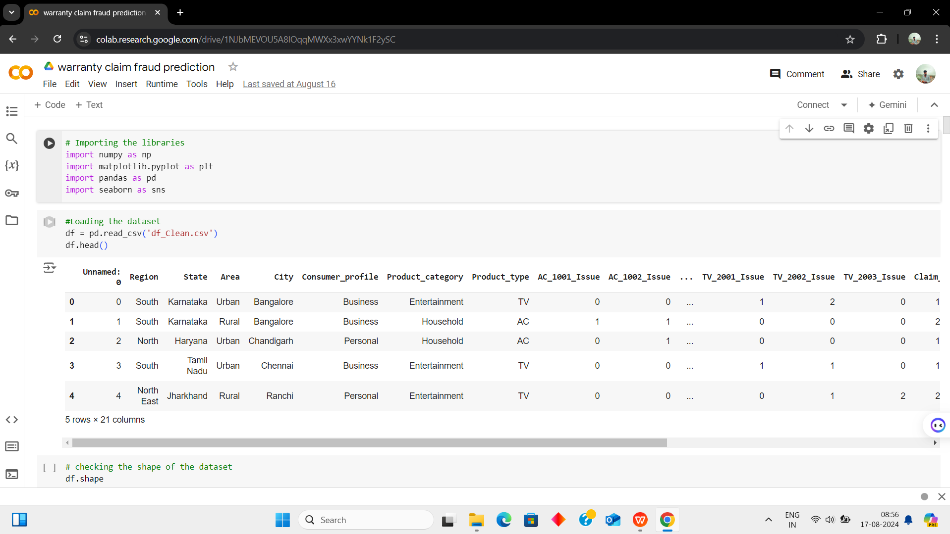

*Fig.A1. Import & Read CSV file.*

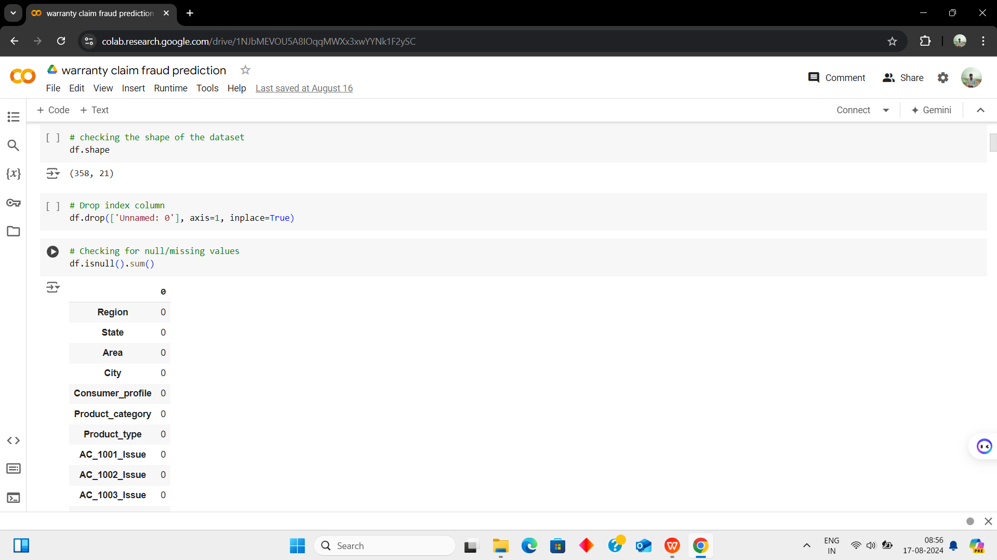

*Fig.A2. Display data and view the shape.*

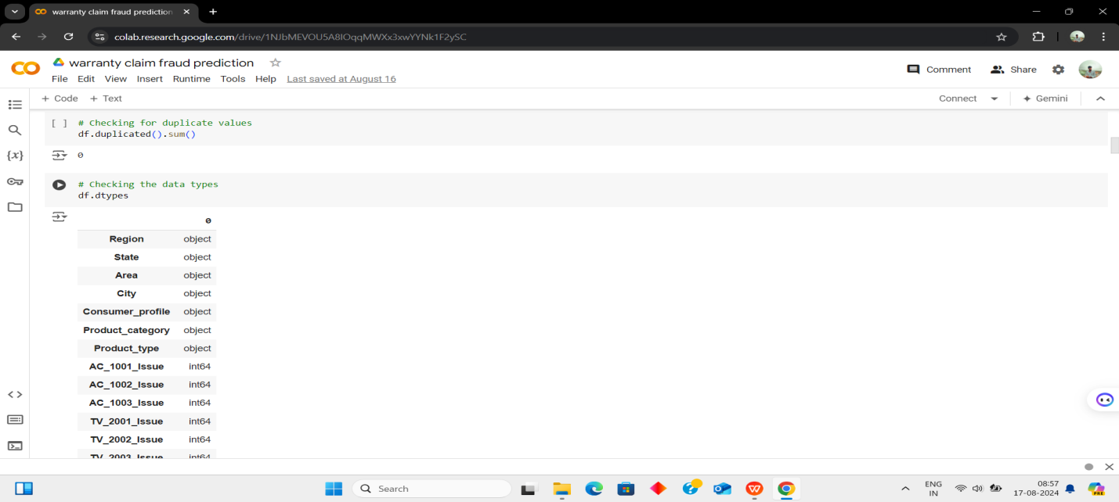

*Fig.A3 Display the duplicated items and data types.*

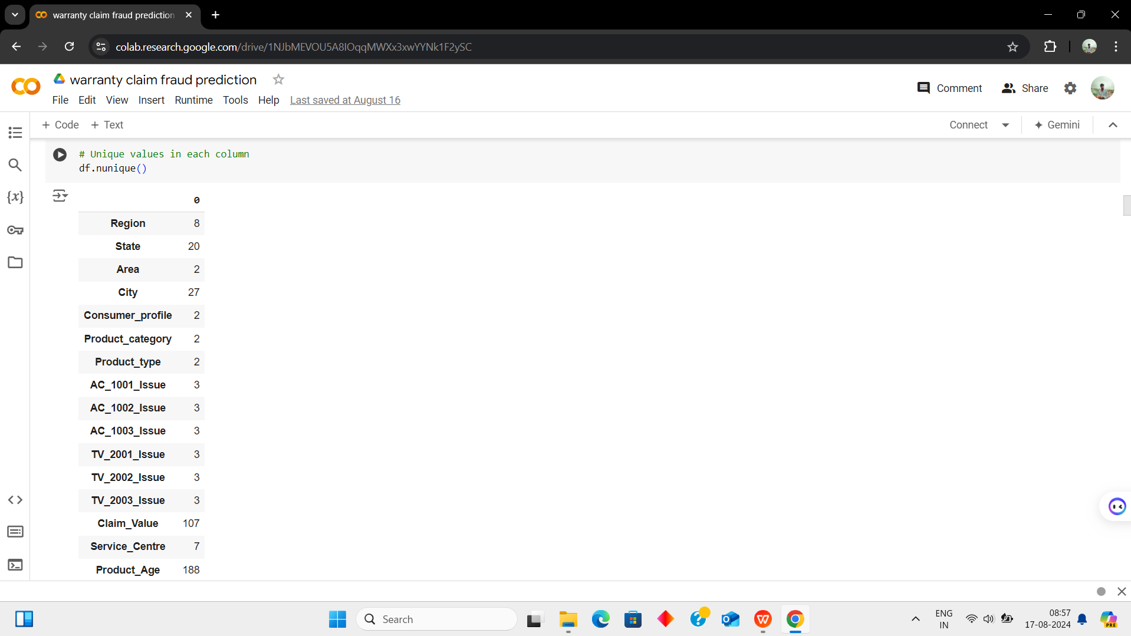

*Fig.A4. Display unique items.*

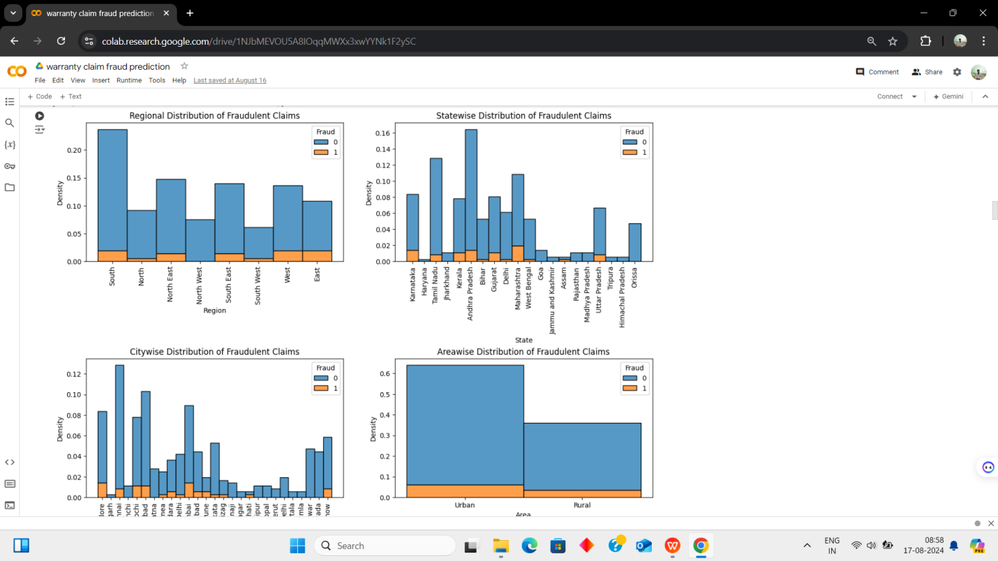

*Fig.A5. Display the fradulent claims.*

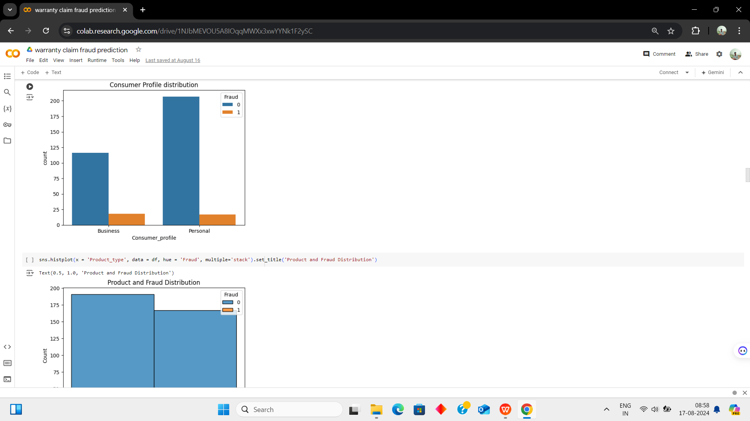

*Fig.A6. Display the consumer profile.*

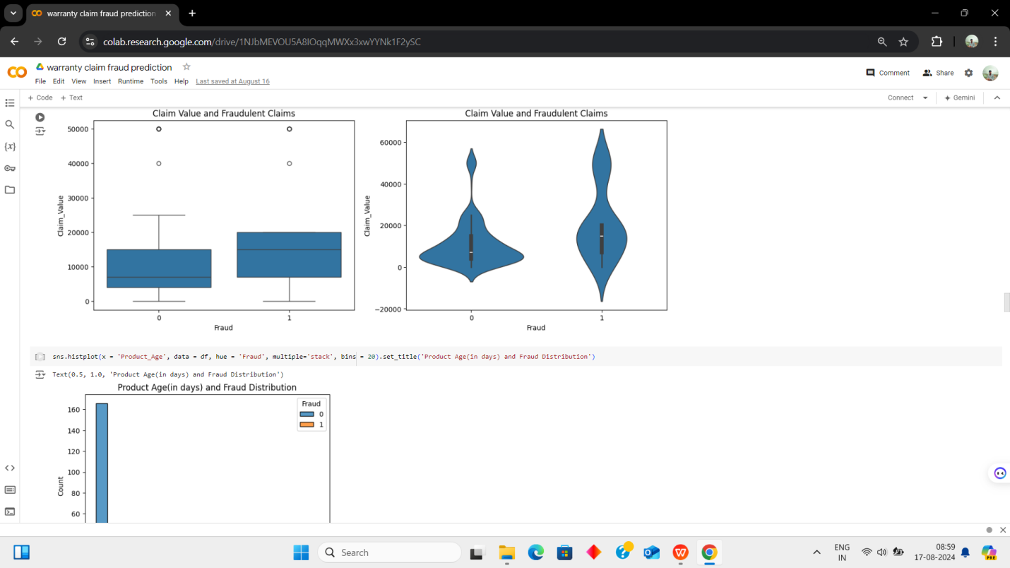

*Fig.A7. Display the claims value and fraudlent claims*

**

*`` Fig.A8. Display the consumer profile.*

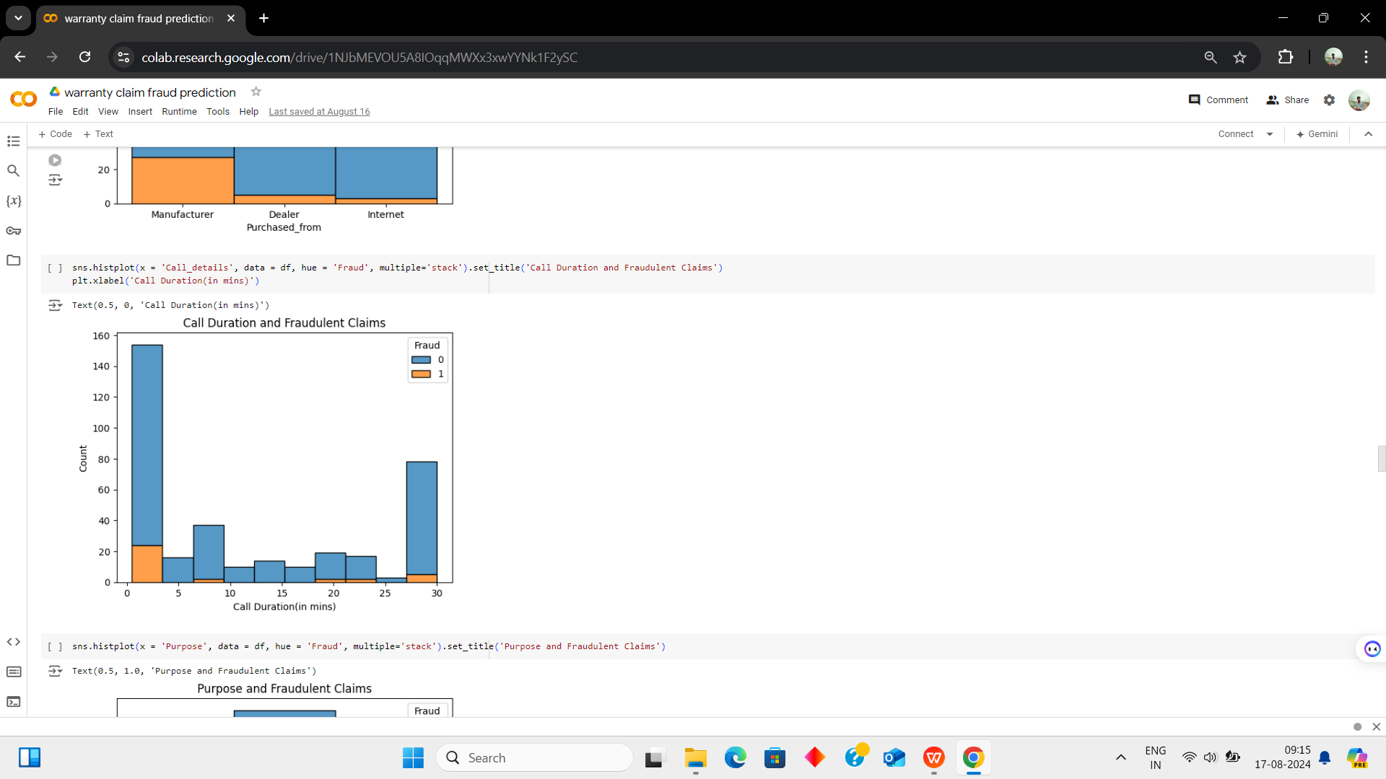

*Fig.A9. Display the call duration and fradulent claims.*

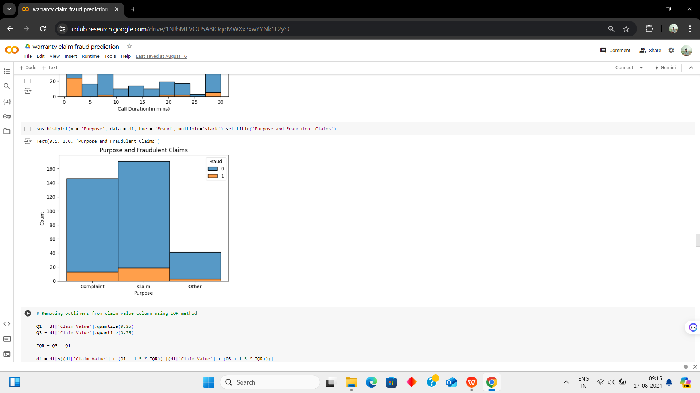

*Fig.A10. Display the purpose and fradulent claims.*

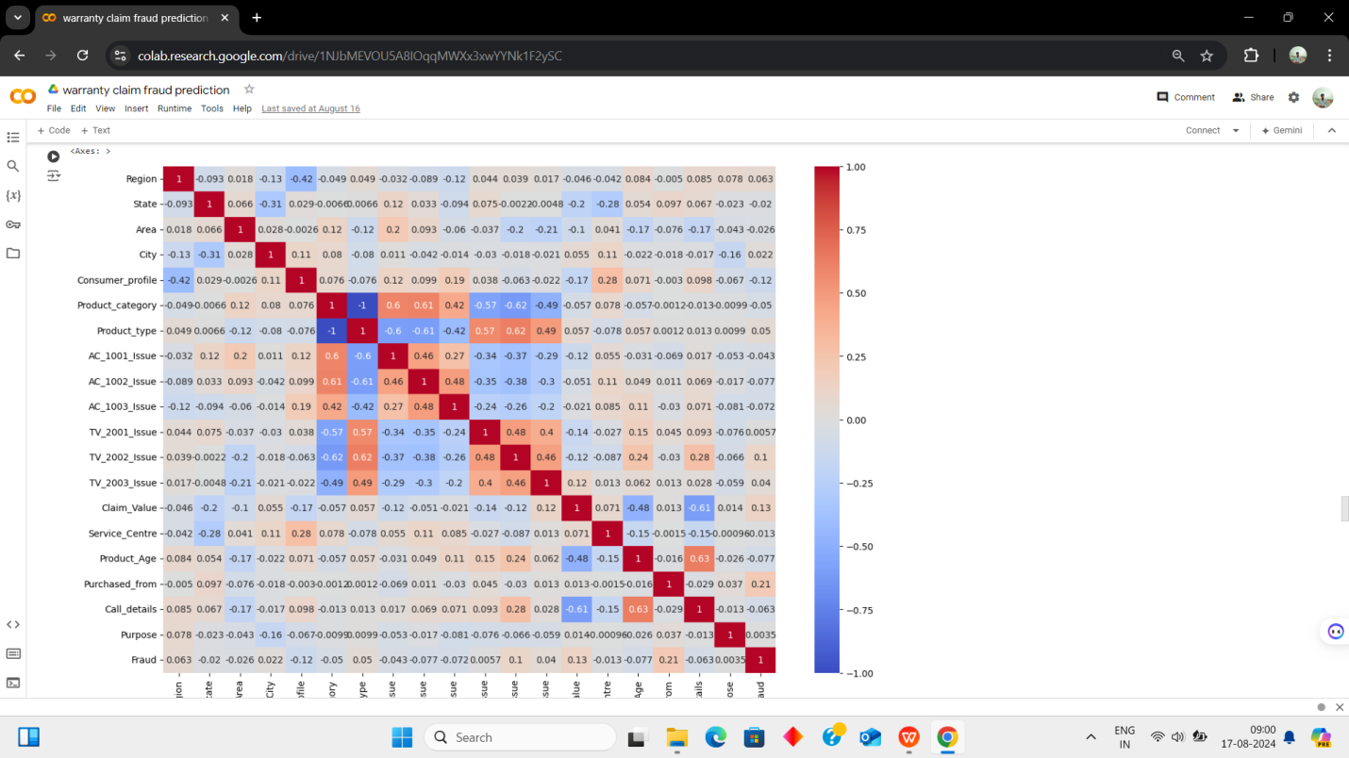

*Fig.A11. Display the axeses*

*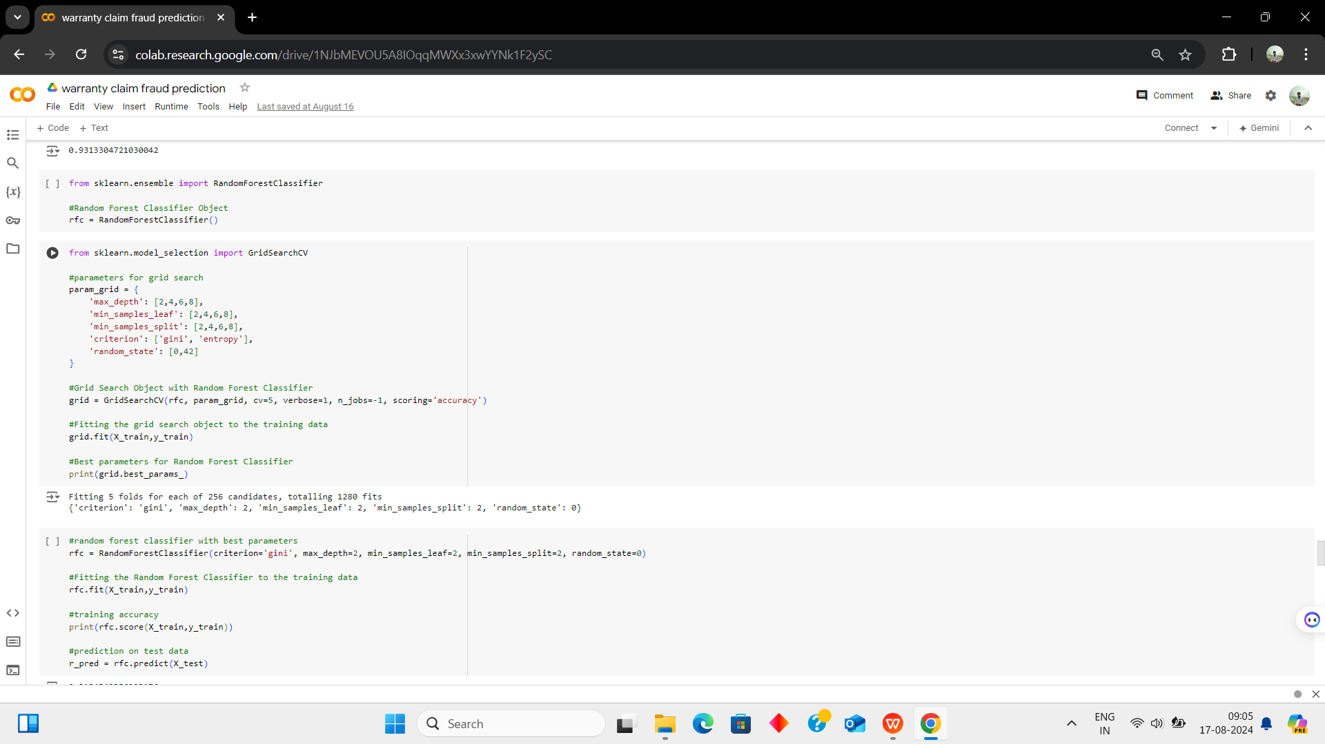.Fig.A12. Displaying the grid search of candidates.*

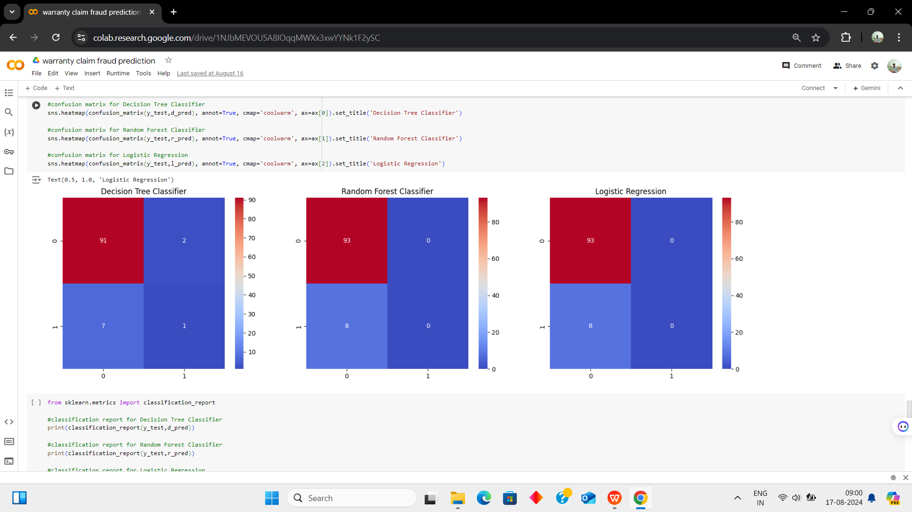

*Fig.A13. Display the decision tree ,random forest ,logistic regression.*

*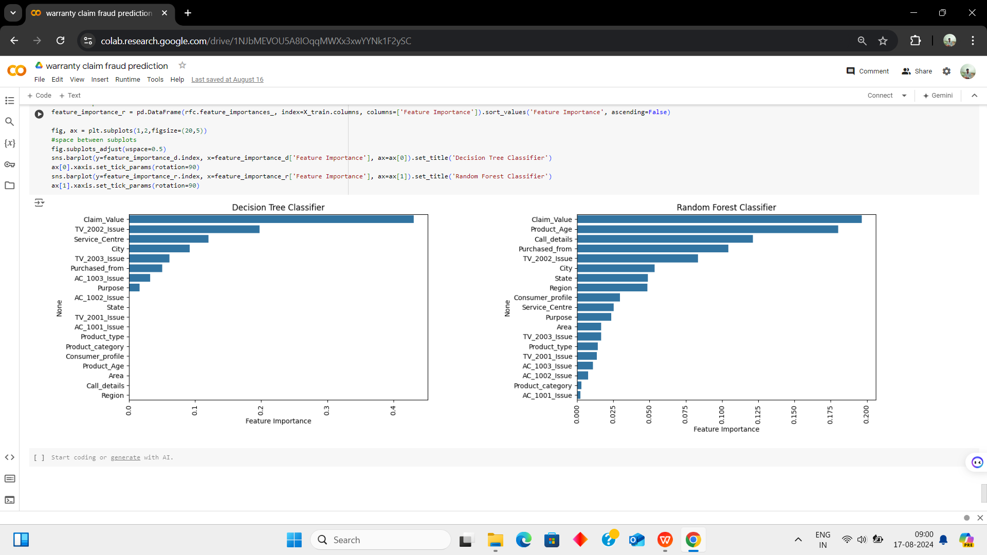.*

*Fig.A14. Display the feature importance of decision tree and random forest classifier.*

**APPENDIX II**

**1."Python Machine Learning" by Sebastian Raschka and Vahid Mirjalili:** Covers data preprocessing, model selection, and evaluation in Python.

**2. "Pattern Recognition and Machine Learning" by Christopher Bishop:** Offers a deep dive into machine learning algorithms and techniques.

**3."Data Science for Business" by Foster Provost and Tom Fawcett:** Explains data science concepts within a business context, including fraud detection.

**4."A Survey of Machine Learning Techniques for Fraud Detection" by Phua et al. (2010)**: A comprehensive review of machine learning methods applied to fraud detection.

**5."A Comprehensive Survey of Data Mining-based Fraud Detection Research" by Ngai et al. (2011**): Discusses various data mining techniques used in fraud detection across different sectors.

**6.Coursera - Machine Learning by Andrew Ng:** An online course that introduces essential machine learning concepts and techniques.

**7. edX - Data Science and Machine Learning Essentials:** A course series covering foundational data science and machine learning skills.

**8."How to Approach Machine Learning for Fraud Detection"**- Towards Data Science (Medium) : Practical guides and case studies related to fraud detection using machine learning.

**9.Scikit-learn Documentation:** Provides detailed explanations of the tools and techniques available in the Scikit-learn library for implementing machine learning models.

**10. Kaggle Competitions and Datasets:** A platform offering datasets and competitions related to fraud detection, along with community-shared notebooks and solutions.